STAGE 2 Chemistry
Assessment Type 1: Investigation Folio
Student Response
Practical Investigation: The effect of percentage of saturated fat on the energy released of combustion
ABSTRACT:
Esters are organic compounds, with common naturally occurring esters being fruit essences, and animal fats and vegetable oils. Animal fats and vegetable oils are triglycerides, which are formed of tri-mesters from propan-1,2,3-triol and long, straight chain carboxylic acids, The aim of this investigation was to examine the effect of the percentage of saturated fats within certain oils on the energy released from combustion. This required using four different sources of oil with ranging percentage of saturated fats, and burning the oil until there was a 10°C increase. The results of the experiment found that as the saturation of the carbon chain increases, the energy released from combustion decreases. This knowledge can be applied to the efficiency of biofuels and the process used to make margarine. Further investigations could also occur to test whether energy released from combustion is increased under different circumstances, such as the unsaturated to saturated ratio or the percentage of unsaturated fats, and if this also produces similar results.
INTRODUCTION:
Esters are organic compounds, with the functional group —COO--, derived from carboxylic acids (APPENDIX ). Carboxylic acids have the structure: R-COOH, where R is the specific carbon chain (APPENDIX ). Common naturally occurring esters include fruit essences, and animal fats and vegetable oils. Animal fats and vegetable oils are triglycerides, which are formed of tri-esters from the triol, propan-1,2,3-triol and long, straight chain carboxylic acids (APPENDIX ). Fats are lipids in a solid state at room temperature while oils are lipids in a liquid state at room temperature.
Knowledge and Understanding
Coherent and effective communication of chemical knowledge.
Fats and oils can be classified as either saturated or unsaturated. Saturated fats and oils consist of triglycerides with no double bonds between the individual carbon atoms of the chain meaning that the chain is "saturated" with hydrogen atoms (APPENDIX ). Unsaturated fats can be broken down into two types: monounsaturated and polyunsaturated. Monounsaturated fats consist of triglycerides with one double bond between its carbon atoms while polyunsaturated fats have many double bonds (APPENDIX ). The presence of double bonds indicates that they are `unsaturated' molecules, which have comparatively less hydrogen atoms attached than saturated molecules.
The melting and boiling points of fats and oil can be related directly to the amount of unsaturation within the carbon chain. As the unsaturation, the double bonds present, increases, the melting point of the oil will decrease. This will then mean that more energy is required for the bonds to break.
Biofuels are a great example of environmental processes which use saturated and unsaturated triglycerides. Vegetable oil is used in conjunction with the process of

esterification, forming esters, to convert the oil into biodiesel fuel. Biodiesel's are one of the most beneficial biofuels as they are renewable, can be degraded by bacteria or other biological compounds, and they produce fewer air pollutants compared to the conventional diesel engines. However, biodiesel's can also cause great harm to the environment as the smog produced from the use of biodiesel has a higher threat to nitric oxide emissions and higher blends may damage the components of engines. Due to these factors, the combustion of oils, particularly the energy that is produced (determined by working out the enthalpy of combustion) has a great impact on the formation of biofuels and the environment.
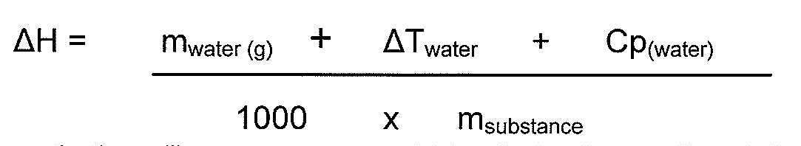
The energy released of combustion (in units' kJg⁻¹) is determined by the following equation

This investigation will use common vegetable oils to discover the relationship between the percentage of saturated fats in certain oils and the energy released from combustion produced. This will help to determine which oils are more beneficial to utilise.
AIM:
The aim of this investigation is to examine the effect of the percentage of saturated fats within certain oils on the energy released of combustion.
HYPOTHESIS:
As the percentage of saturated fats within oils increases, the energy released of combustion will also increase due to the saturation of the carbon chains and the strong dispersion forces between the triglyceride molecules.
INDEPENDENT VARIABLE:
- The independent variable is the percentage of saturated fats of apricot kernel, safflower. canola and sunflower oil.
DEPENDANT VARIABLE:
- The dependant variable is the energy released of combustion measured in kJg⁻¹.
- CONTROLLED VARIABLES:
- The temperature rise before calculating the energy released of combustion (each solution had to rise 10°C.
- The angle of parallax to measure out solutions
- The amount of H₂O within the beaker

MATERIALS:
- Retort stand  - Clamp  - Matches  - Tea light holder  - Wick  - Copper wire  - 50 ml beaker | - Alfoil  - Polystyrene cups  - 25 ml beakers x 4  - Water  - Thermometer x 2  - Scales

METHOD:
Several methods were tested before a final procedure was outlined. Refer to Appendix
- Set up a retort stand and collect a 25 ml beaker. The beaker needs to be clamped to the stand roughly 1/3 from the bottom of the stand.
- Next collect two polystyrene cups. On the first cup cut out the bottom circle and on the second cup, cut the top off leaving the base and approximately 5 cm left of the sides of the cup. Poke a hole through the centre of the base in this cup.
- Using scissors cut holes in the side of the polystyrene cup. This will allow oxygen flow to travel through the cup.
- Using alfoil, cover the remaining bit of cup left. The alfoil will serve as a protector so that the polystyrene does not burn.
- Fill the 25ml beaker, set up in the retort stand, with water and place the thermometer through the hole in the smaller insulator and rest thermometer into the 25m1 beaker filled with water
- Collect a tea light candle holder and fill half-way with an oil.
- Cut a piece of wick about 3 cm long and using copper wire tie a loose loop around the wick and join the wire underneath the tea light holder.
- Weigh the tea light holder (including the wick and copper wire) and record.
- Place the tea light holder on a white tile, light the wick and place the insulating polystyrene cup over top.
- Observe the current temperature and after a 10° C increase blow out the wick and weigh the candle holder again.
Investigation
Well considered and clear design
- Compare the final mass as opposed to the initial mass you recorded.
- Repeat experiment for all 4 different oils.

EVIDENCE OF PRACTICAL:
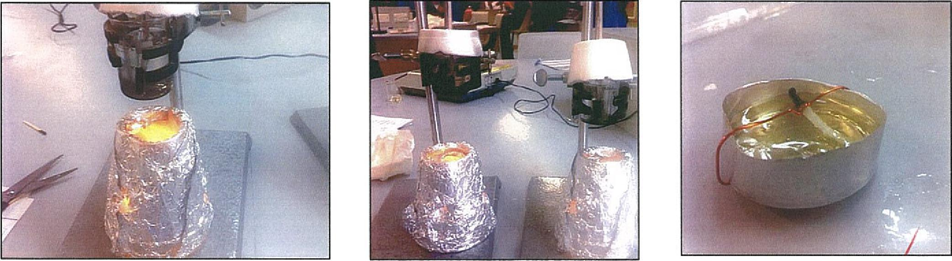
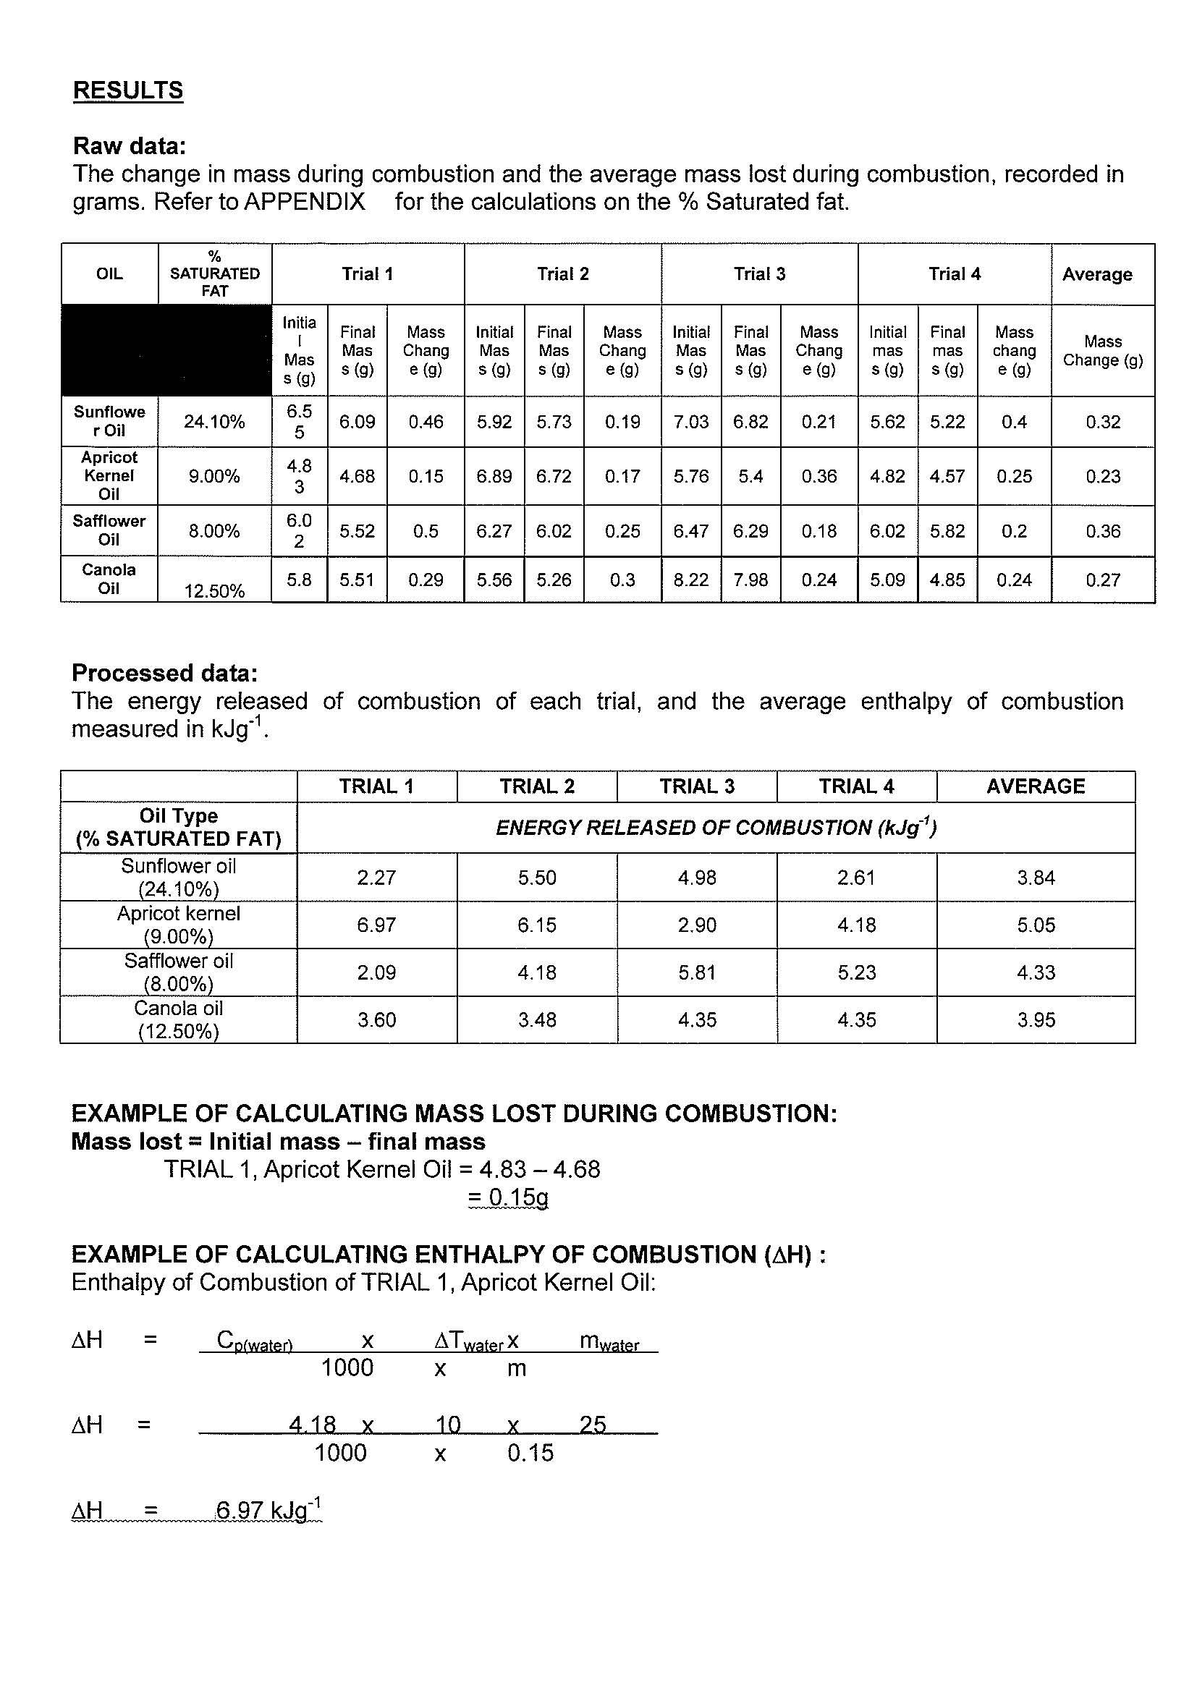

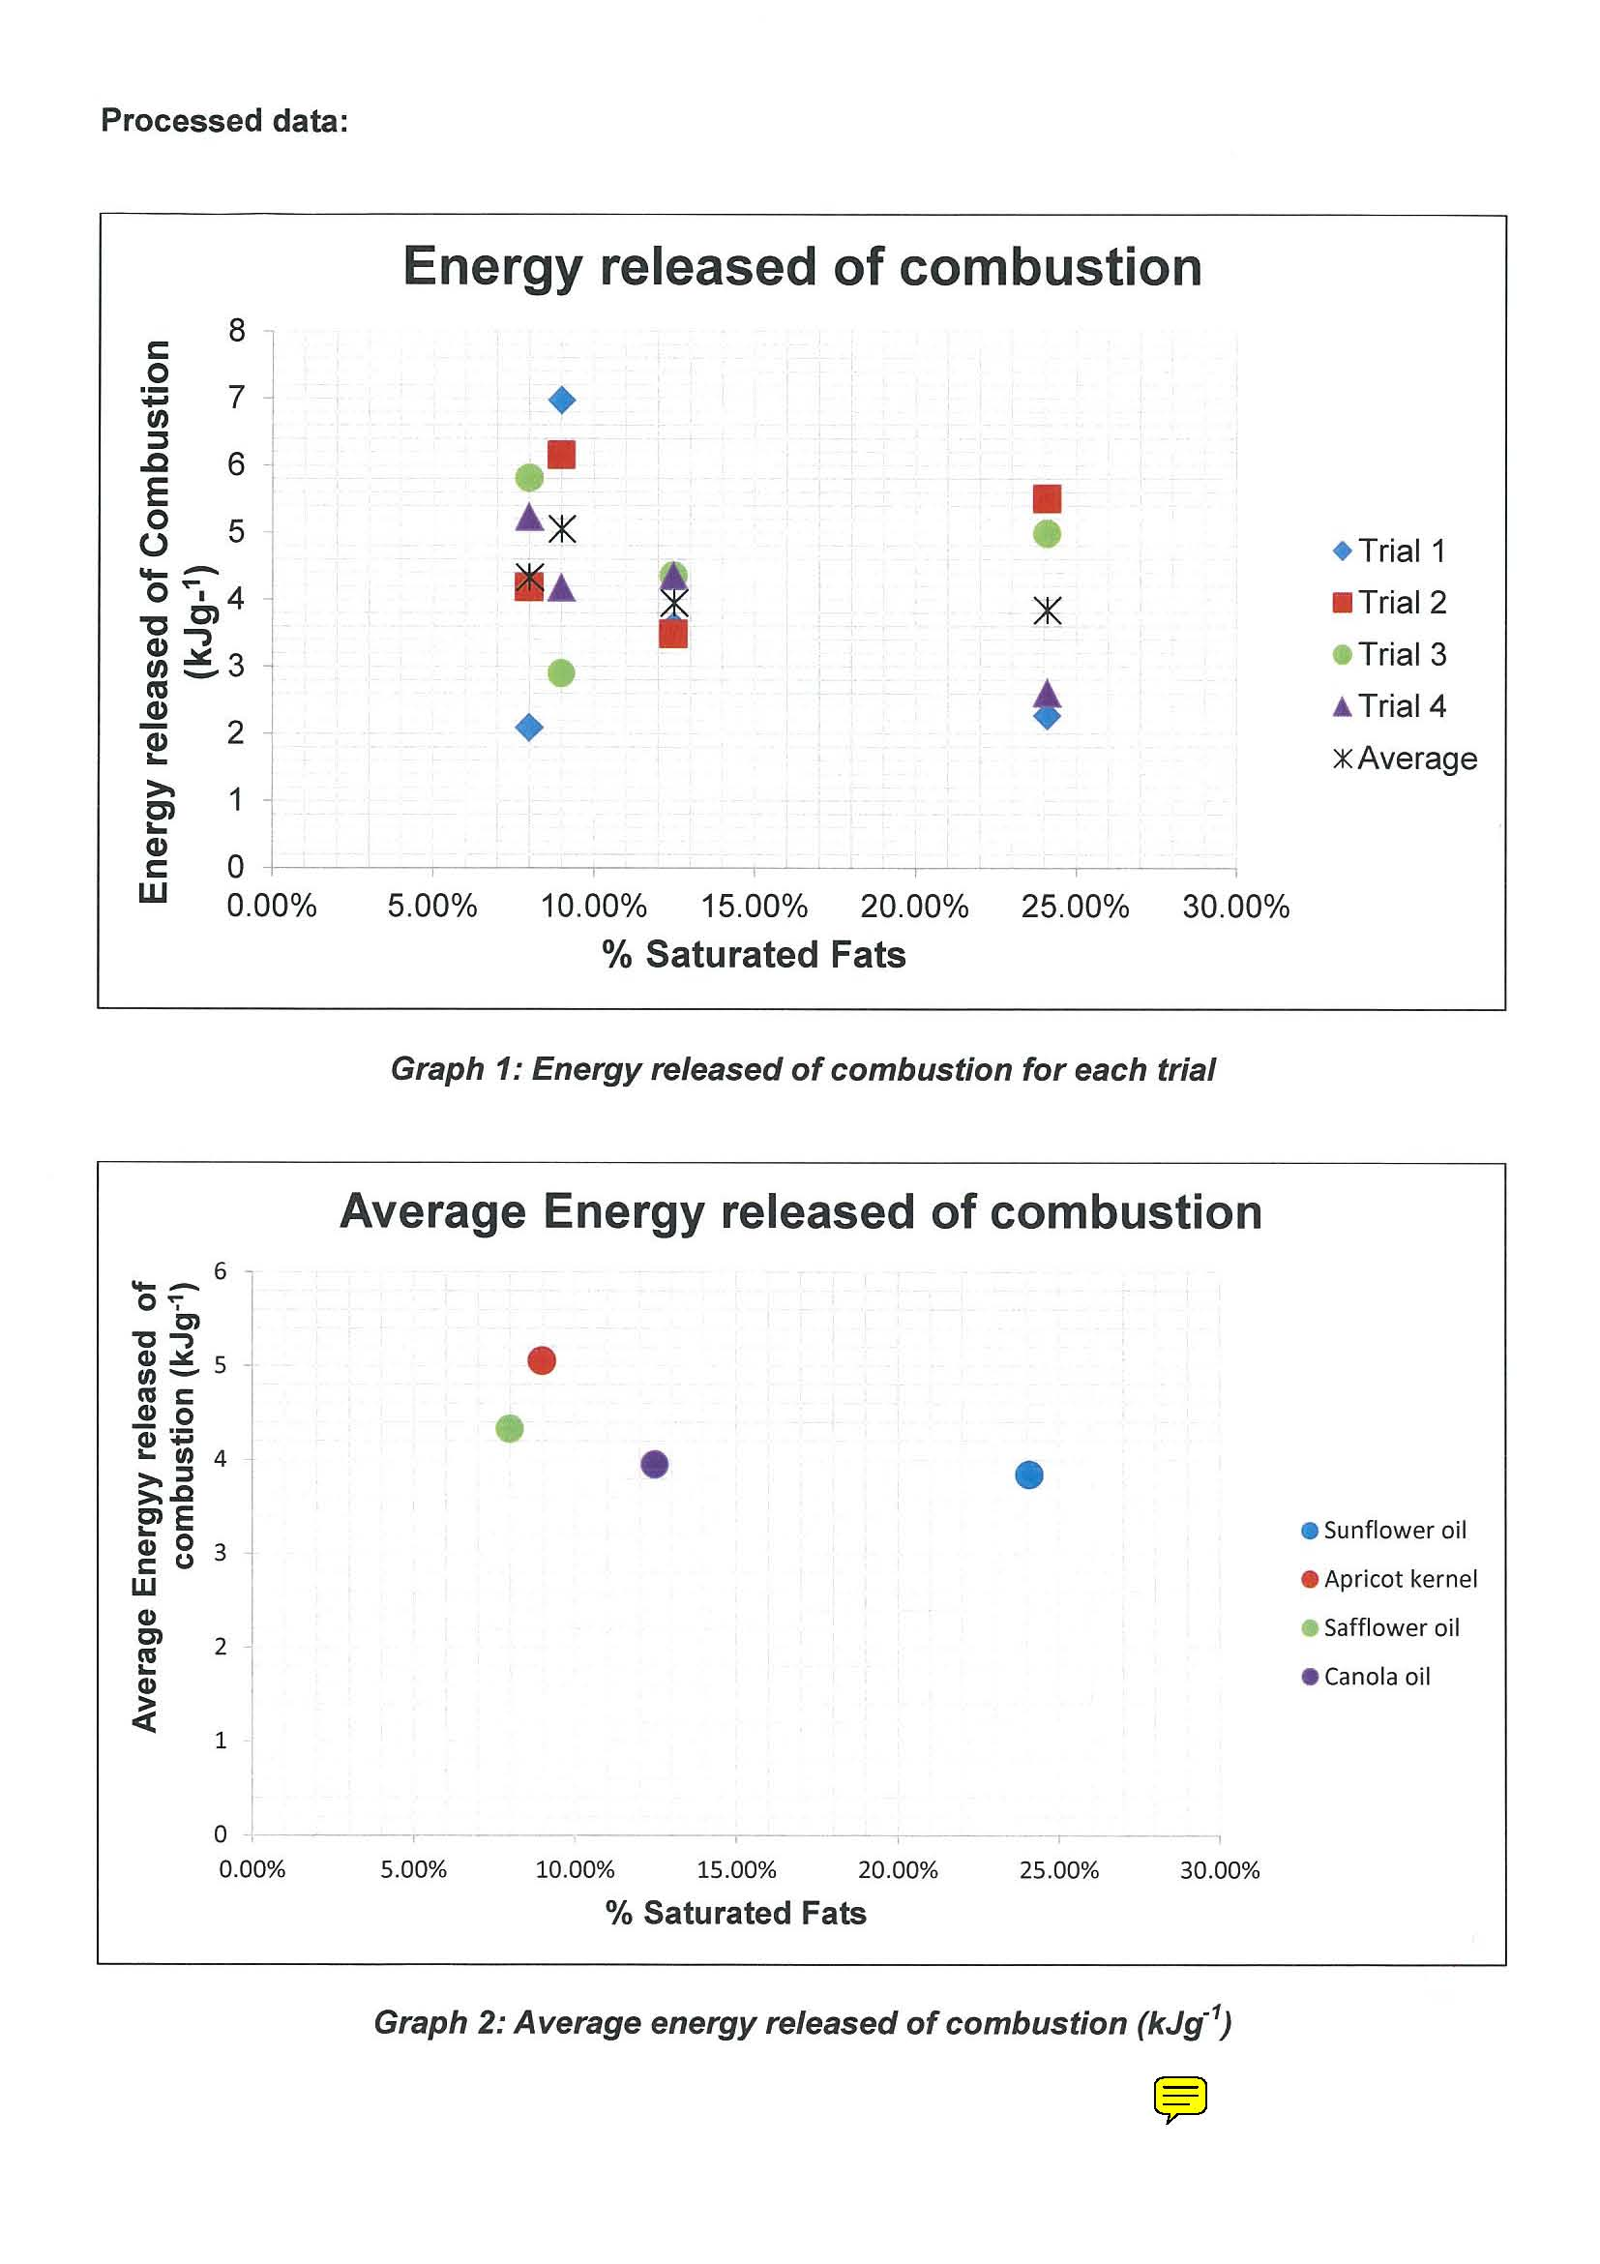
Investigation
Appropriate conventions and formats used mostly appropriately and effectively.

CONCLUSION:
The enthalpy of combustion will decrease when the percentage of saturated fats in the carbon chain increases. This did not support the initial hypothesis of the experiment. Graph 2 shows that the highest enthalpy produced occurred during the apricot kernel oil with a percentage of saturated fat of 9.00%. This shows inaccuracy in the data collected however because the highest enthalpy should have been produced at Sunflower Oil with a percentage of 24.10%.
The outliers seen in graph 1 convey the lack of precision, through the scatter of the data points, which occurred in some trials and therefore can be attributed to many of the errors within the experiment. Due to the inaccuracy of the results, the hypothesis should be re-tested by completing the experiment again, with higher percentages as this would prove whether the results of this experiment are reliable.
Further investigations could also occur to test whether enthalpy of combustion is increased under different circumstances, such as the unsaturated to saturated ratio or the percentage of unsaturated fats, and if this also produces similar results.
Analysis and Evaluation
Generally logical analysis of data connected to concepts.
Discussion and Analysis
Graph 'I conveys the enthalpy of combustion that occurred for each separate trial performed during the experiment and can therefore be used to analyse the precision of the data collected. From the graph it is shown that the most precise data was the canola oil with a percentage saturated fat of 12.5% as there is less spread between the data points in comparison to the other oils. It is also shown that the data collected for apricot kernel oil with percentage saturated fat of 9.00% was also relatively precise as there is an even data spread between the points. The least precise data was collected from the safflower and sunflower oil where the data spread is quite large. The presence of outliers in these oils confirms that random errors occurred within the investigation.
Graph 2 is the average enthalpy of combustion that transpired over all the trials that were performed during the experiment. From the graph it can be shown that there is inaccuracy in the results. The hypothesis stated that as the percentage of saturated fat in oil increases, the enthalpy of combustion would also increase. However, the results show that this is not true with the enthalpy of combustion produced higher at apricot kernel oil, than at canola oil, with 8.00%and 12.50% respectively. As the saturated triglycerides are packed tightly together, their dispersion forces are stronger and the bonds are harder to break, therefore more energy is required to break the bonds. In the experiment, the sunflower oil with percentage of saturated fats of 24.10% should have produced the highest enthalpy out of the oils tested as it has the highest percentage of saturated triglycerides within the carbon chain meaning that a higher enthalpy would be required to break the bonds of the sunflower oil.

Evaluation
There is a possibility of random errors which may have affected the results, and these are identified by outliers. One source of random error is the resolution on the measuring cylinder used. The measuring cylinders do not have a high resolution and due to this, the beaker of water could have contained more or less than the constant 25m1 of water that was required.
There was a random error in the insulation device used for the experiment. As shown in APPENDIX the insulator used on the water began to burn away toward the end of the experiment. This could have let heat that was given off escape and affect the results as the earlier trials were done will full insulation. This would have influenced the precision of the data as the insulator was not kept constant throughout the experiment.

The length and surface area of the wicks were not kept constant and were a source of random errors. This meant that the flame was spread out over a larger area during some of the trials and not in others.
The air movement also would have affected the flame as it would not have been kept constant at some stages due to draughts.
Another source of random error was that soot could be seen on the base of the calorimeter during the experiments (this is also shown in APPENDIX V). This meant that not all the energy given off from the alcohol would have heated the water. The presence of soot shows that incomplete combustion occurred during the experiment. Incomplete combustion is shown in the equation:
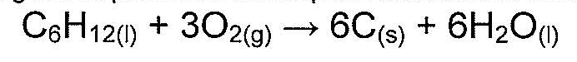
The oxygen flow during the experiment was a large source of random errors during the experiment. The pressure on the copper wire was a design error and would have interrupted the flow of oxygen, and the flow of the oil, from the candle holder to the wick. The distance between the flame and the beaker were also not kept constant and this meant that there was more oxygen flowing to one wick than there was to the others.
Another random error could be found if there were fluctuations in the room temperature during the experiment. The effects of this would be minimal however and may not have a significant consequence on the data collected. The effects of these random errors could have been reduced if a larger sample size were utilised during the experiment.
Analysis and Evaluation
Procedures evaluated with some logic.
One systematic error that occurred in this experiment was the calibration of the scales. The scales were not calibrated and due to this the results produced would not be accurate. A test after the experiment found that the scales used were not calibrated by 1.91% and 5.82% under what they should have been. This affected the results a lot and calibration of the scales should have been done before the beginning of the experiment.

Another source of systematic error was that not all the energy released from the combustion would have been absorbed into the water in the beaker. A significant amount of the heat energy is absorbed by the surrounding air of the flame.
Another systematic error found from problems in the method of the experiment occurred in the type of thermometer used for each trial. This was not kept controlled and differences in the design of the thermometers and their calibration would have affected the data collected. This would mean that the heat rise for some oils would have been greater than others.
The combustion of the oil is carried out in the air and therefore it is not complete combustion. This would mean that a portion of the oil undergoes incomplete combustion. The systematic errors in this experiment are the reason for the low accuracy of the results.
SUGGESTIONS FOR IMPROVEMENT:
To ensure accurate and reliable data, different oils could have been tested in accordance with a greater range of percentage saturated fat. This would make the results broader and allow comparing and contrasting between the results. The presence of two sets of data would also add more support to the connection between the percentage of saturated fat and energy released from combustion.
A higher temperature rise could be utilised to improve the investigation. This investigation let the temperature rise by 1O and then measured the mass lost or gained however if the temperature was increased this would this would allow more of a mass change to occur.

example, 5-10 trials should be completed for each oil to allow for a more accurate average. The treatment size should also be increased, using percentages lower than 8.00% but also higher than the 24.00% and having percentages ranging in amount. This would also improve the quality of the results collected as the data will be broader.
By utilising a calibration test, with a known mass, the scales should have been calibrated before the experiment began. This would have ensured that the correct measurements were being collected and throughout the experiment the same scales should been used to avoid any differences. This would have influenced the accuracy of the experiment.
The heat energy that was lost during the experiment to the air should be reduced by changing the design of the experiment to let the minimalist amount of heat energy escape. This could be improved by using a better insulator and ensuring that only the required amount of oxygen for the flame to burn is allowed through.
Analysis and Evaluation
Some generally appropriate improvements suggested.

APPLICATION:
Saturated triglycerides are a major contributor to the high blood cholesterol levels found in many humans. High amounts of saturated fats in the diet can increase the amount of 'bad cholesterol', This can lead to fatty deposits building in arteries and causing them to narrow which increase the risk of heart blockages.
Knowledge of the effect that the saturated triglycerides have on oils is required to understand the process that is used to make margarine. It is prepared by a vegetable oil being heated with hydrogen gas in the presence of a nickel catalyst. The hydrocarbon chains of the oil become more saturated, meaning less double bonds are present. From here, hydrogen is added which helps to form a solid at room temperature.
The process of esterification is used in conjunction with saturated and unsaturated hydrocarbons to form the biofuel, biodiesel. Esterification requires a vegetable oil, alcohol in the form of either methyl or ethyl and a catalyst. Fuels with a high enthalpy of combustion produce more power than fuels with a lower energy. Due to this engines with a lower energy fuel require more fuel to produce the same power as diesel fuel. As hydrocarbons that have a higher percentage of saturation require more energy to combust, fuels that are saturated would be a higher energy fuel and therefore more efficient to use than fuels with a lower energy or diesel fuel.
Knowledge and Understanding
Coherent and effective communication of chemical knowledge.

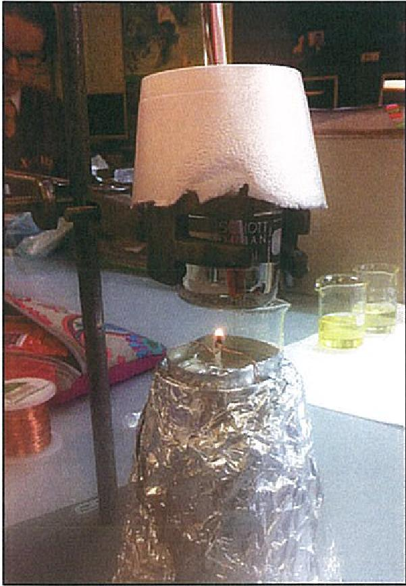 | The initial design of the experiment  Comments:  As shown in the photograph, the flame produced by the wick was small and it was dying out sooner than the temperature was reaching the 10°C increase that was required. This could be due to a number of factors. It can be seen that there is not an effective oxygen flow that would be getting through to the candle. The copper wire may also have been a cause of the wick burning out if it was pulled to tight around the wick further restricting oxygen flow and the oil seeping into the wick.

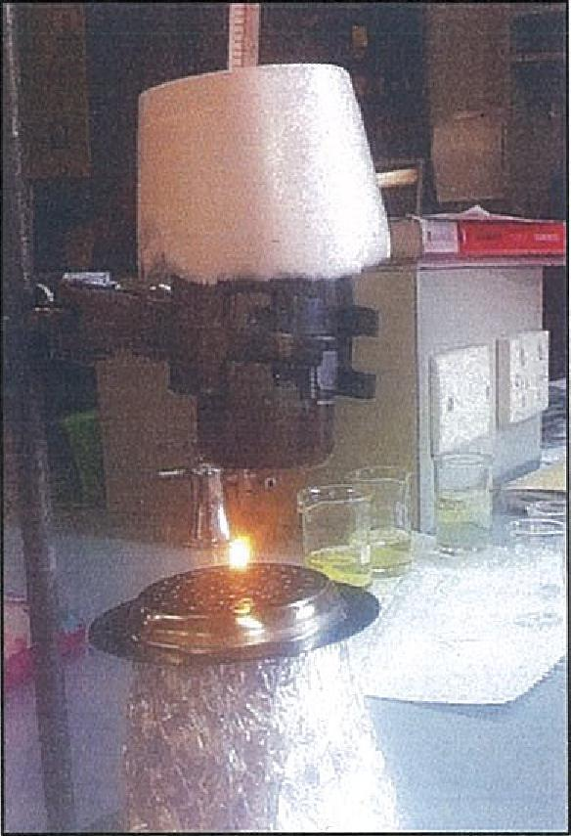 | Design number two Comments:  This was the second method of resign utilised by my group. We discovered that by using a the wick would be able tostand up by itself and another bonus was that it brought the wick closer to the bottom of the beaker without the beaker to be moved lower. This design also had to be changed however because the perforated (?) holes were cutting of a steady flow of oxygen to the wick which meant it was burning up fast just like the previous design.

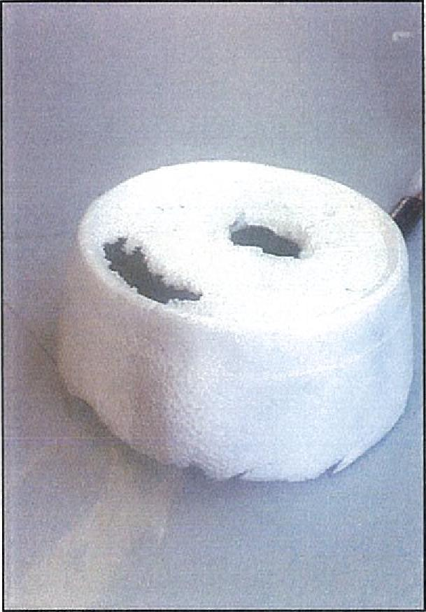 |  | Insulating Error  Comments:  After the experiment, it was discovered that the polystyrene that was being used as an insulator for the beaker and thermometer had started to burn and produce holes. This meant that for some of the trials the insulation was not kept constant and affects the data collected as it is not an accurate representation of how much the enthalpy of combustion should have been.

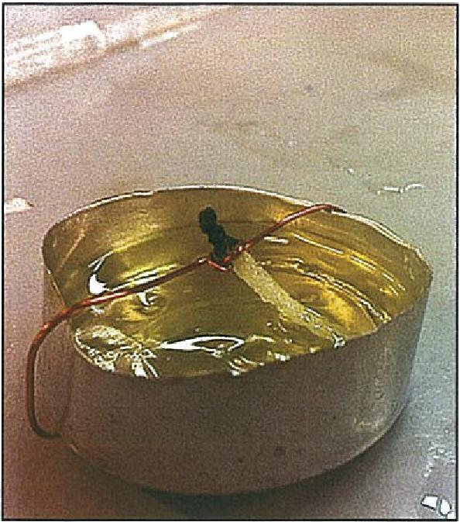 | Design of the wick  Comments:  This is the final design of the wick that decided upon. Initially the use of copper wire resulted in the wick burning out faster than the temperature rise needed to be but after re-evaluating the cause for this, the wire was tied looser around the wick as to not interfere with the oil transferring from wick to the candle holder and not interfere with the oxygen flow as well.

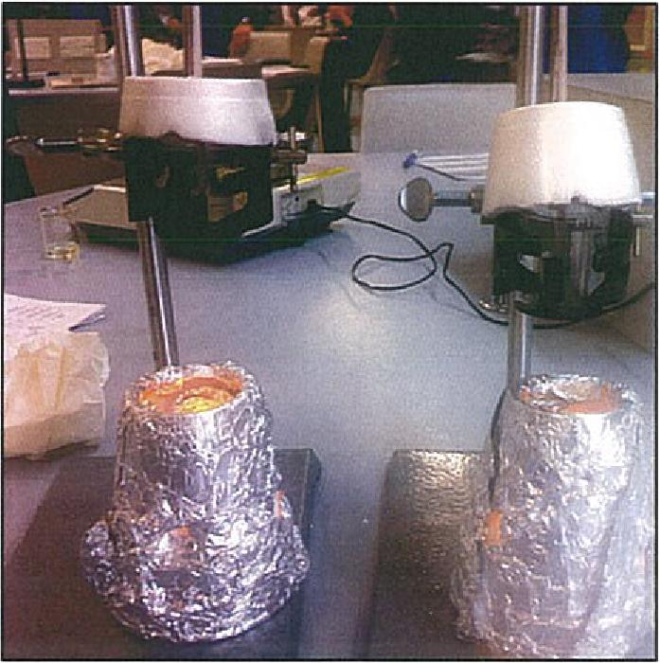 | Final design of experiment  Comments:  This design proved to be the most effective as the oxygen flow was under control more and it produced positive results, allowing the temperature to reach the 10° increase that was required.

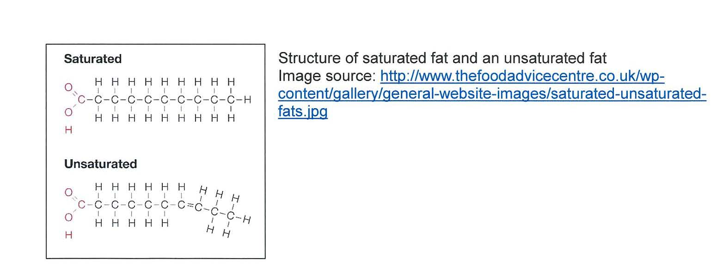

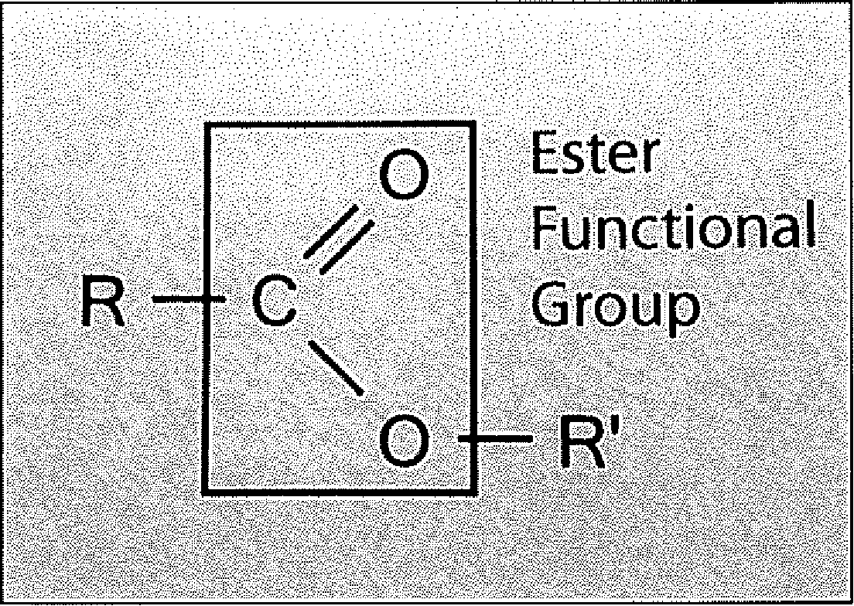

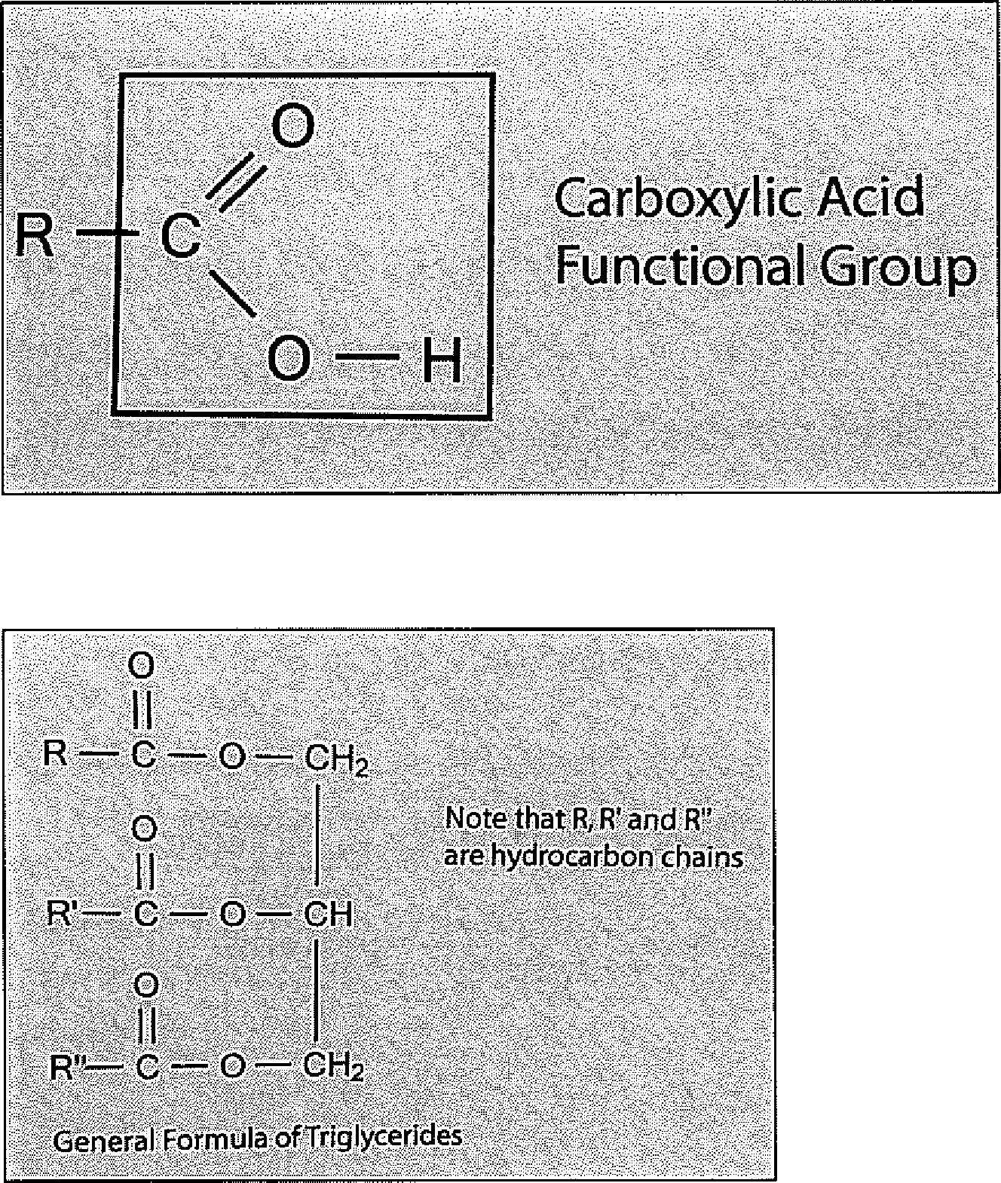
Functional Group
BIBLIOGRAPHY:
BBC. (2011). Plant oils and food additives. Available:
http://vvvvw.bbc.co. uldschoo Is/gcsebitesize/scien ce/aqa_pre_2011/oils/p la ntoilsrevl.shtml. Last accessed 12th Aug 2012.
Dieticians Association of Australia. (2012). Saturated Fats. Available: http://daa.asn.au/for-thepublic/smart-eating-for-you/nutrition-a-z/saturated-fats/. Last accessed 12th Aug 2012.
Evans, C; McCann, M and Morton, B (2012) Chemistry Workbook: SACE Stage 2, 7th ed. South Australia, Adelaide Tuition Centre
Fitday. (2011). Saturated vs. Unsaturated Fatty Acids. Available: http://www.fitday.com/fitnessarticles/nutrition/fats/saturated-vs-unsaturated-fatty-acids.html#b. Last accessed 12th Aug 2012.
Fogoros, R. (2011). Cholesterol and Triglycerides - What You Need To Know. Available: http://heartdisease.about.com/od/cholesteroltriglyceridel /a/Cholesterol-And-Triglycerides. htm . Last accessed 12th Aug 2012.
Haynes, F. (2012). Understanding Fats. Available:
http://lowfatcooking.about.com/od/lowfatbasics/a/fats1004.htm. Last accessed 12th Aug 2012.
Heart Foundation of Australia. (2012). Saturated Fats. Available:
http://www.heartfoundation.org.au/healthy-eating/fats/Pages/saturated-fats.aspx. Last accessed 12th Aug 2012.
Holloway, R.B; Joyce, D.E; Reynolds, S and Stanley, R.J. (2000). Discovering Chemistry 2. South Australia: The Enterprise Press. p316-319.
Moll, J. (2011). What Is The Difference Between Unsaturated and Saturated Fats?. Available: http://cholesterol.about.com/cs/faq/f/difference.htm. Last accessed 12th Aug 2012.
NutriStrategy. (2010). Fats, Cooking Oils and Fatty Acids. Available: http://www.nutristrategy.com/fatsoils.htm. Last accessed 12th Aug 2012.
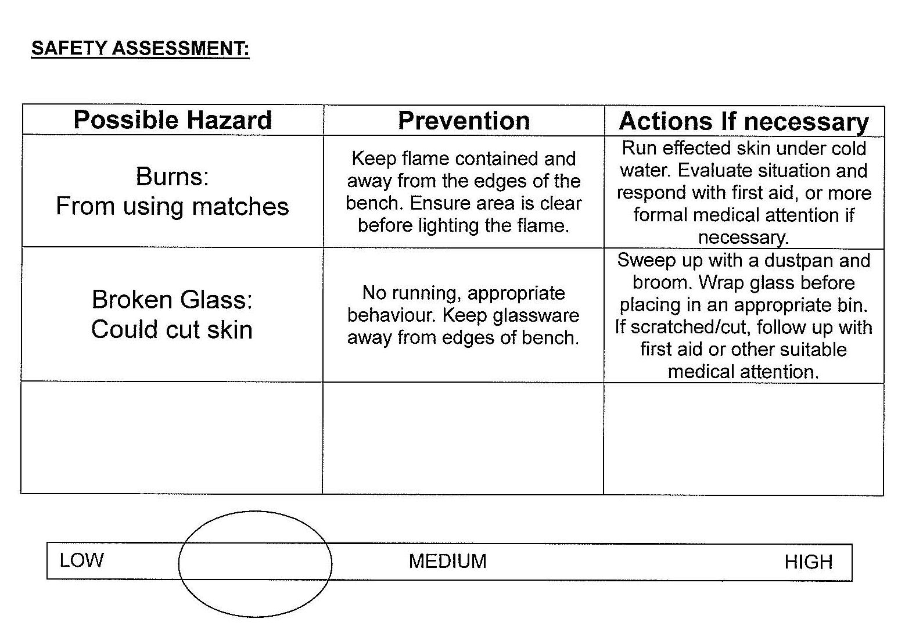

Teacher Checklist for A3
Skill | very good | good | satisfactory | poor | limited
Collaboration in  discussion/development of plan | ✓
Collaboration in preliminary laboratory work | ✓
Collaboration in final investigation | ✓
Individual initiative and focus during investigation |  | ✓
Leadership demonstrated throughout investigation |  | ✓

Performance Standards for Stage 2 Chemistry
 | Investigation | Analysis and Evaluation |  | Application | Knowledge and Understanding
A | Designs logical, coherent, and detailed chemistry investigations.  Critically and logically selects and consistently and appropriately acknowledges information about chemistry and issues in chemistry from a range of sources.  Manipulates apparatus and technological tools carefully and highly effectively to implement well-organised safe and ethical investigation procedures.  Obtains, records, and displays findings of investigations using appropriate conventions and formats accurately and highly effectively. |  | Critically and systematically analyses data and their connections with concepts to formulate logical and perceptive conclusions and make relevant predictions.  Critically and logically evaluates procedures and suggests a range of appropriate improvements. | Applies chemistry concepts and evidence from investigations to suggest solutions to complex problems in new and familiar contexts.  Uses appropriate chemical terms, conventions, formulae, and equations highly effectively.  Demonstrates initiative in applying constructive and focused individual and collaborative work skills. |  | Consistently demonstrates a deep and broad knowledge and understanding of a range of chemistry concepts.  Uses knowledge of chemistry perceptively and logically to understand and explain social or environmental issues.  Uses a variety of formats to communicate knowledge and understanding of chemistry coherently and highly effectively.
B | Designs well-considered and clear chemistry investigations.  Logically selects and appropriately acknowledges information about chemistry and issues in chemistry from different sources.  Manipulates apparatus and technological tools carefully and mostly effectively to implement organised safe and ethical investigation procedures.  Obtains, records, and displays findings of investigations using appropriate conventions and formats mostly accurately and effectively. |  | Clearly and logically analyses data and their connections with concepts to formulate consistent conclusions and make mostly relevant predictions.  Logically evaluates procedures and suggests some appropriate improvements. | Applies chemistry concepts and evidence from investigations to suggest solutions to problems in new and familiar contexts.  Uses appropriate chemical terms, conventions, formulae, and equations effectively.  Applies mostly constructive and focused individual and collaborative work skills. |  | Demonstrates some depth and breadth of knowledge and understanding of a range of chemistry concepts.  Uses knowledge of chemistry logically to understand and explain social or environmental issues.  Uses a variety of formats to communicate knowledge and understanding of chemistry coherently and effectively.
C | Designs considered and generally clear chemistry investigations.  Selects with some focus, and mostly appropriately acknowledges, information about chemistry and issues in chemistry from different sources.  Manipulates apparatus and technological tools generally carefully and effectively to implement safe and ethical investigation procedures.  Obtains, records, and displays findings of investigations using generally appropriate conventions and formats with some errors but generally accurately and effectively. |  | Analyses data and their connections with concepts to formulate generally appropriate conclusions and make simple predictions with some relevance.  Evaluates some procedures in chemistry and suggests some improvements that are generally appropriate. | Applies chemistry concepts and evidence from investigations to suggest some solutions to basic problems in new or familiar contexts.  Uses generally appropriate chemical terms, conventions, formulae, and equations with some general effectiveness.  Applies generally constructive individual and collaborative work skills. |  | Demonstrates knowledge and understanding of a general range of chemistry concepts.  Uses knowledge of chemistry with some logic to understand and explain one or more social or environmental issues.  Uses different formats to communicate knowledge and understanding of chemistry with some general effectiveness.
D | Prepares the outline of one or more chemistry investigations.  Selects and may partly acknowledge one or more sources of information about chemistry or an issue in chemistry.  Uses apparatus and technological tools with inconsistent care and effectiveness and attempts to implement safe and ethical investigation procedures.  Obtains, records, and displays findings of investigations using conventions and formats inconsistently, with occasional accuracy and effectiveness. |  | Describes basic connections between some data and concepts and attempts to formulate a conclusion and make a simple prediction that may be relevant.  For some procedures, identifies improvements that may be made. | Applies some evidence to describe some basic problems and identify one or more simple solutions, in familiar contexts.  Attempts to use some chemical terms, conventions, formulae, and equations that may be appropriate.  Attempts individual work inconsistently, and contributes superficially to aspects of collaborative work. |  | Demonstrates some basic knowledge and partial understanding of chemistry concepts.  Identifies and explains some chemistry information that is relevant to one or more social or environmental issues.  Communicates basic information to others using one or more formats.
E | Identifies a simple procedure for a chemistry investigation.  Identifies a source of information about chemistry or an issue in chemistry.  Attempts to use apparatus and technological tools with limited effectiveness or attention to safe or ethical investigation procedures.  Attempts to record and display some descriptive information about an investigation, with limited accuracy or effectiveness. |  | Attempts to connect data with concepts, formulate a conclusion and make a prediction.  Acknowledges the need for improvements in one or more procedures. | Identifies a basic problem and attempts to identify a solution in a familiar context.  Identifies some chemical terms or formulae.  Shows emerging skills in individual and collaborative work. |  | Demonstrates some limited recognition and awareness of chemistry concepts.  Shows an emerging understanding that some chemistry information is relevant to social or environmental issues.  Attempts to communicate information about chemistry.

Additional Comments
Some teachers have found this format of the performance standards useful in making assessment decisions for an individual task.
Performance Standards for Stage 2 Chemistry
 | A | B | C | D | E
Investigation | Designs logical, coherent, and detailed chemistry investigations.  Critically and logically selects and consistently and appropriately acknowledges information about chemistry and issues in chemistry from a range of sources.  Manipulates apparatus and technological tools carefully and highly effectively to implement well-organised safe and ethical investigation procedures.  Obtains, records, and displays findings of investigations using appropriate conventions and formats accurately and highly effectively. | Designs well-considered and clear chemistry investigations.  Logically selects and appropriately acknowledges information about chemistry and issues in chemistry from different sources.  Manipulates apparatus and technological tools carefully and mostly effectively to implement organised safe and ethical investigation procedures.  Obtains, records, and displays findings of investigations using appropriate conventions and formats mostly accurately and effectively. | Designs considered and generally clear chemistry investigations.  Selects with some focus, and mostly appropriately acknowledges, information about chemistry and issues in chemistry from different sources.  Manipulates apparatus and  technological tools generally carefully and effectively to implement safe and ethical investigation procedures.  Obtains, records, and displays findings of investigations using generally appropriate conventions and formats with some errors but generally accurately and effectively. | Prepares the outline of one or more chemistry investigations.  Selects and may partly acknowledge one or more sources of information about chemistry or an issue in chemistry.  Uses apparatus and technological tools with inconsistent care and effectiveness and attempts to implement safe and ethical investigation procedures.  Obtains, records, and displays findings of investigations using conventions and formats inconsistently, with occasional accuracy and effectiveness. | Identifies a simple procedure for an chemistry investigation.  Identifies a source of information about chemistry or an issue in chemistry.  Attempts to use apparatus and technological tools with limited effectiveness or attention to safe or ethical investigation procedures.  Attempts to record and display some descriptive information about an investigation, with limited accuracy or effectiveness.
Analysis and Evaluation | Critically and systematically analyses data and their connections with concepts to formulate logical and perceptive conclusions and make relevant predictions.  Critically and logically evaluates procedures and suggests a range of appropriate improvements. | Clearly and logically analyses data and their connections with concepts to formulate consistent conclusions and make mostly relevant predictions.  Logically evaluates procedures and suggests some appropriate improvements. | Analyses data and their connections with concepts to formulate generally appropriate conclusions and make simple predictions with some relevance.  Evaluates some procedures in chemistry and suggests some improvements that are generally appropriate. | Describes basic connections between some data and concepts and attempts to formulate a conclusion and make a simple prediction that may be relevant.  For some procedures, identifies improvements that may be made. | Attempts to connect data with concepts, formulate a conclusion and make a prediction.  Acknowledges the need for improvements in one or more procedures.
Application | Applies chemistry concepts and evidence from investigations to suggest solutions to complex problems in new and familiar contexts.  Uses appropriate chemistry terms, conventions, formulae, and equations highly effectively.  Demonstrates initiative in applying constructive and focused individual and collaborative work skills. | Applies chemistry concepts and evidence from investigations to suggest solutions to problems in new and familiar contexts.  Uses appropriate chemistry terms, conventions, formulae, and equations effectively.  Applies mostly constructive and focused individual and collaborative work skills. | Applies chemistry concepts and evidence from investigations to suggest some solutions to basic problems in new or familiar contexts.  Uses generally appropriate chemistry terms, conventions, formulae, and equations with some general effectiveness.  Applies generally constructive individual and collaborative work skills. | Applies some evidence to describe some basic problems and identify one or more simple solutions, in familiar contexts.  Attempts to use some chemistry terms, conventions, formulae, and equations that may be appropriate.  Attempts individual work inconsistently, and contributes superficially to aspects of collaborative work. | Identifies a basic problem and attempts to identify a solution in a familiar context.  Uses some chemistry terms or formulae.  Shows emerging skills in individual and collaborative work.
Knowledge and Understanding | Consistently demonstrates a deep and broad knowledge and understanding of a range of chemistry concepts and practices.  Uses knowledge of chemistry perceptively and logically to understand and explain social, economic, or environmental issues.  Uses a variety of formats to communicate knowledge and understanding of chemistry coherently and highly effectively. | Demonstrates some depth and breadth of knowledge and understanding of a range of chemistry concepts and practices.  Uses knowledge of chemistry logically to understand and explain social, economic, or environmental issues.  Uses a variety of formats to communicate knowledge and understanding of chemistry coherently and effectively. | Demonstrates knowledge and understanding of a general range of chemistry concepts and practices.  Uses knowledge of chemistry with some logic to understand and explain one or more social, economic, or environmental issues.  Uses different formats to communicate knowledge and understanding of chemistry with some general effectiveness. | Demonstrates some basic knowledge and partial understanding of chemistry concepts and/or practices.  Identifies and explains some chemistry information that is relevant to one or more social, economic, or environmental issues.  Communicates basic information to others using one or more formats. | Demonstrates some limited recognition and awareness of chemistry concepts or practices.  Shows an emerging understanding that some chemistry information is relevant to social, economic, or environmental issues.  Attempts to communicate information about chemistry.

